**ITE5315 Assignment 2**

**N01579863 – Kush Patel**

**Web programming and Framework 1**

**Step 1: Create new Node/Express app as follow**

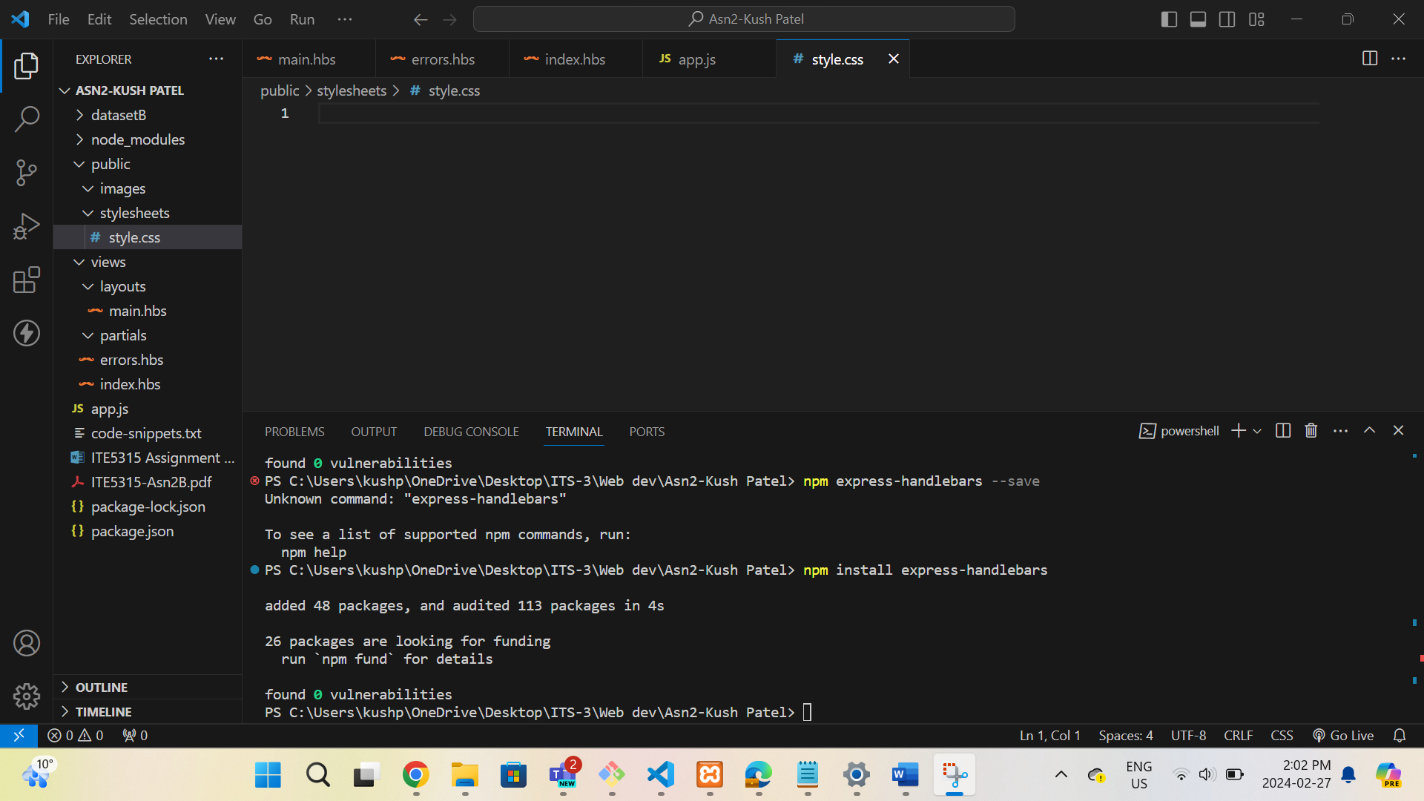

**Step 2: Using the attach file (codenippet.txt), copy/paste the related code to “style.css”,**

**“main.hbs”, “index.hbs”, “error.hbs” and “app.js”.**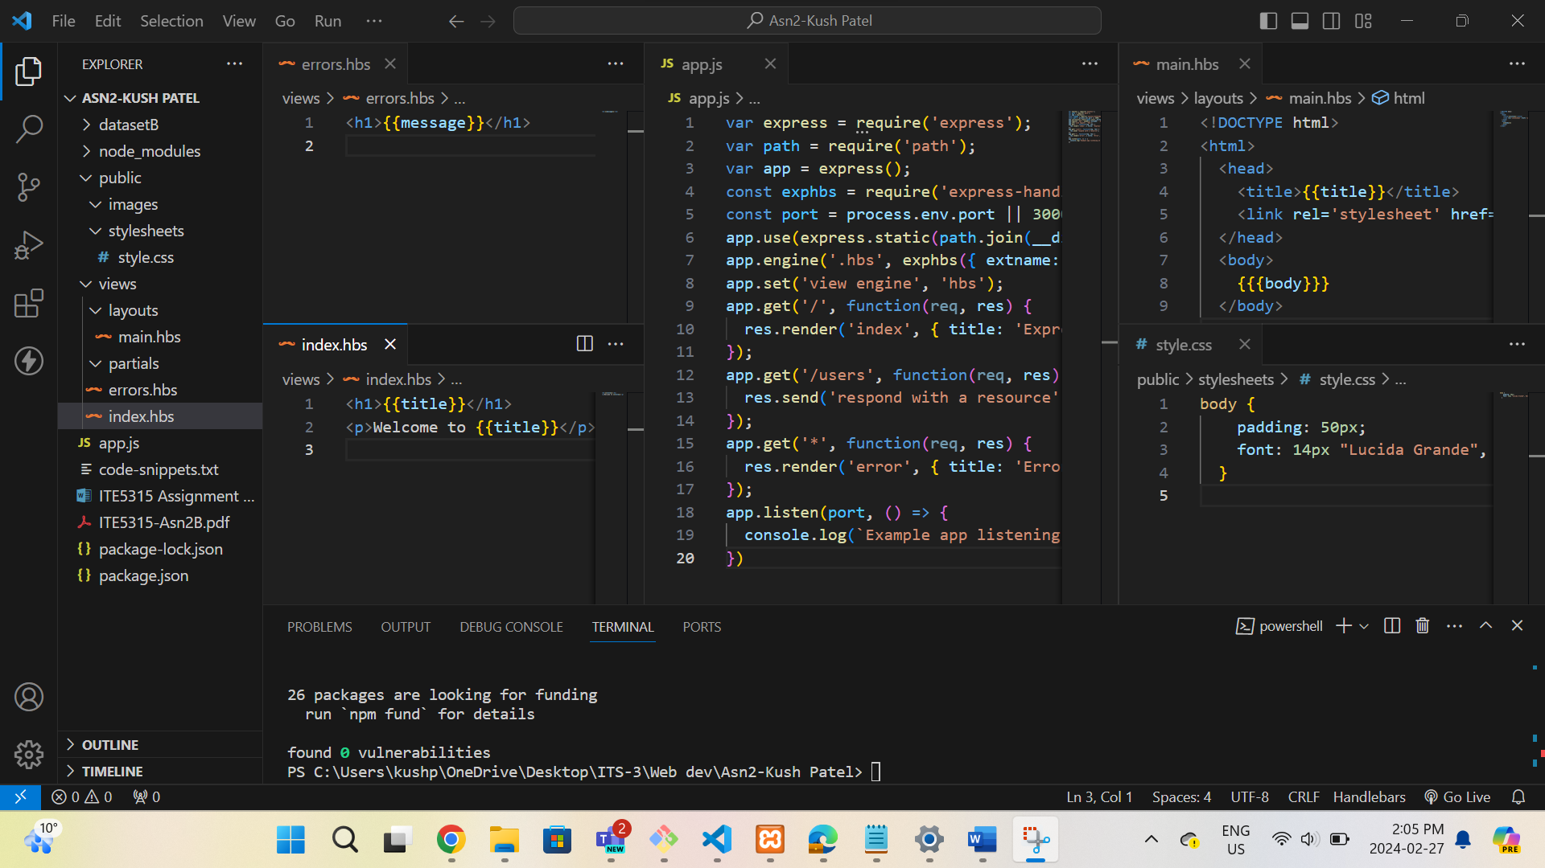

**Step 3:**

**URL: http://localhost:3000/**

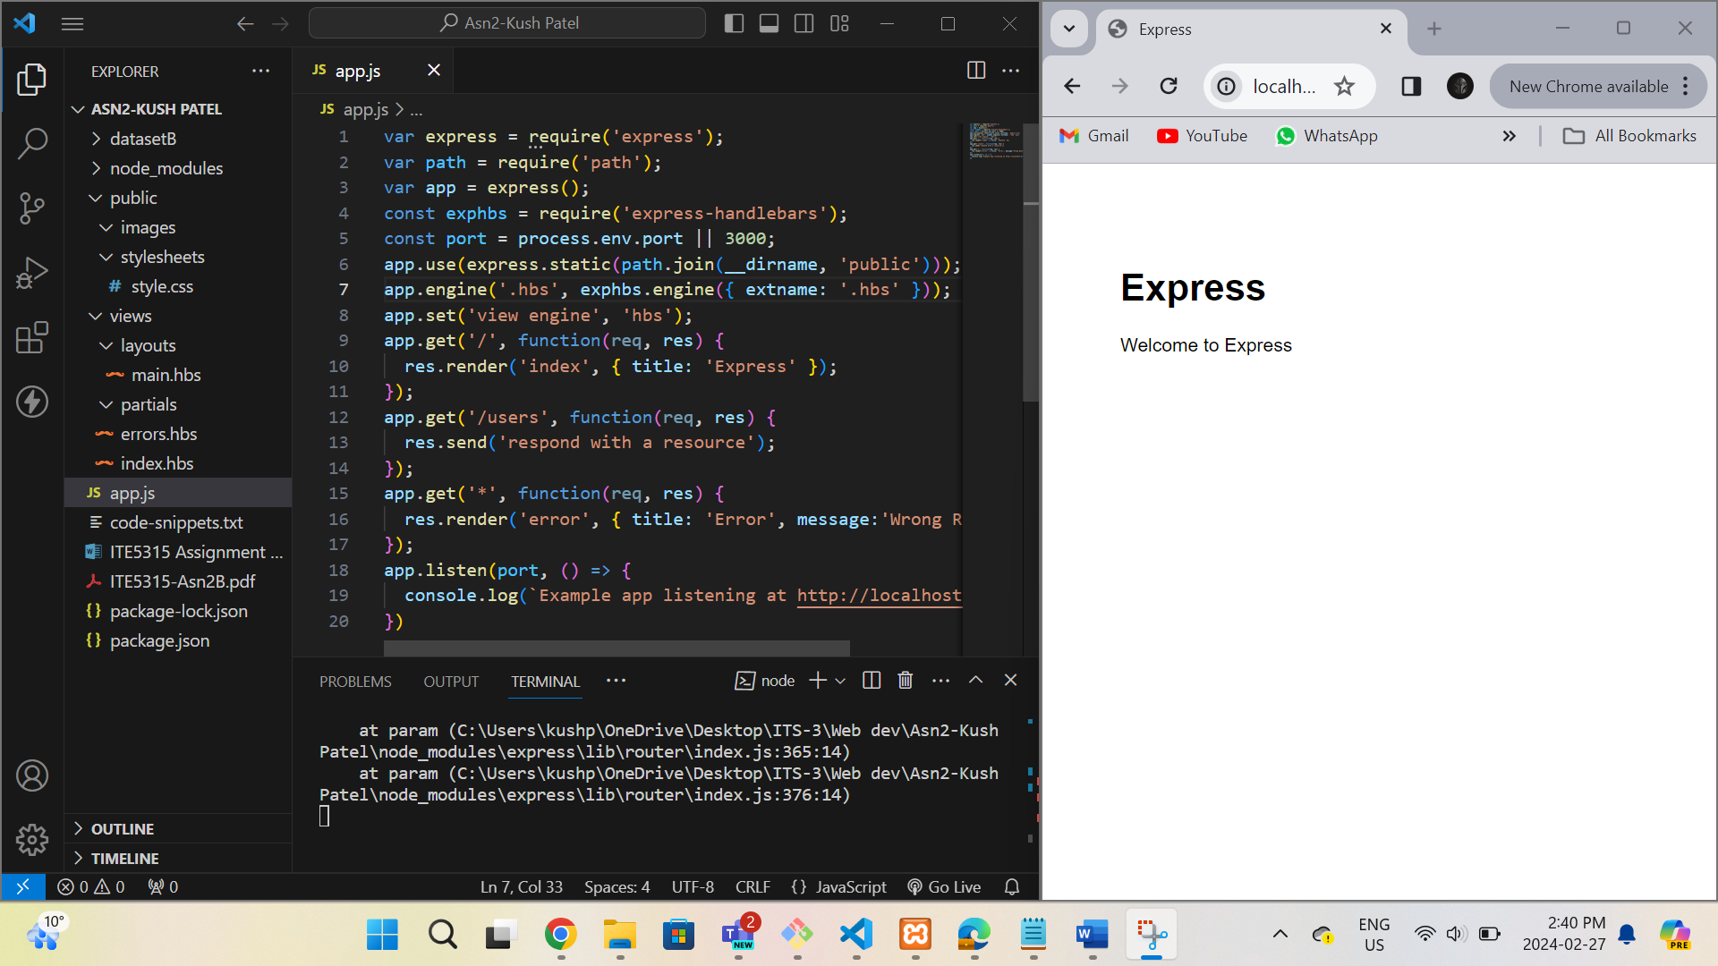

**URL:** [**http://localhost:3000/users**](http://localhost:3000/users)

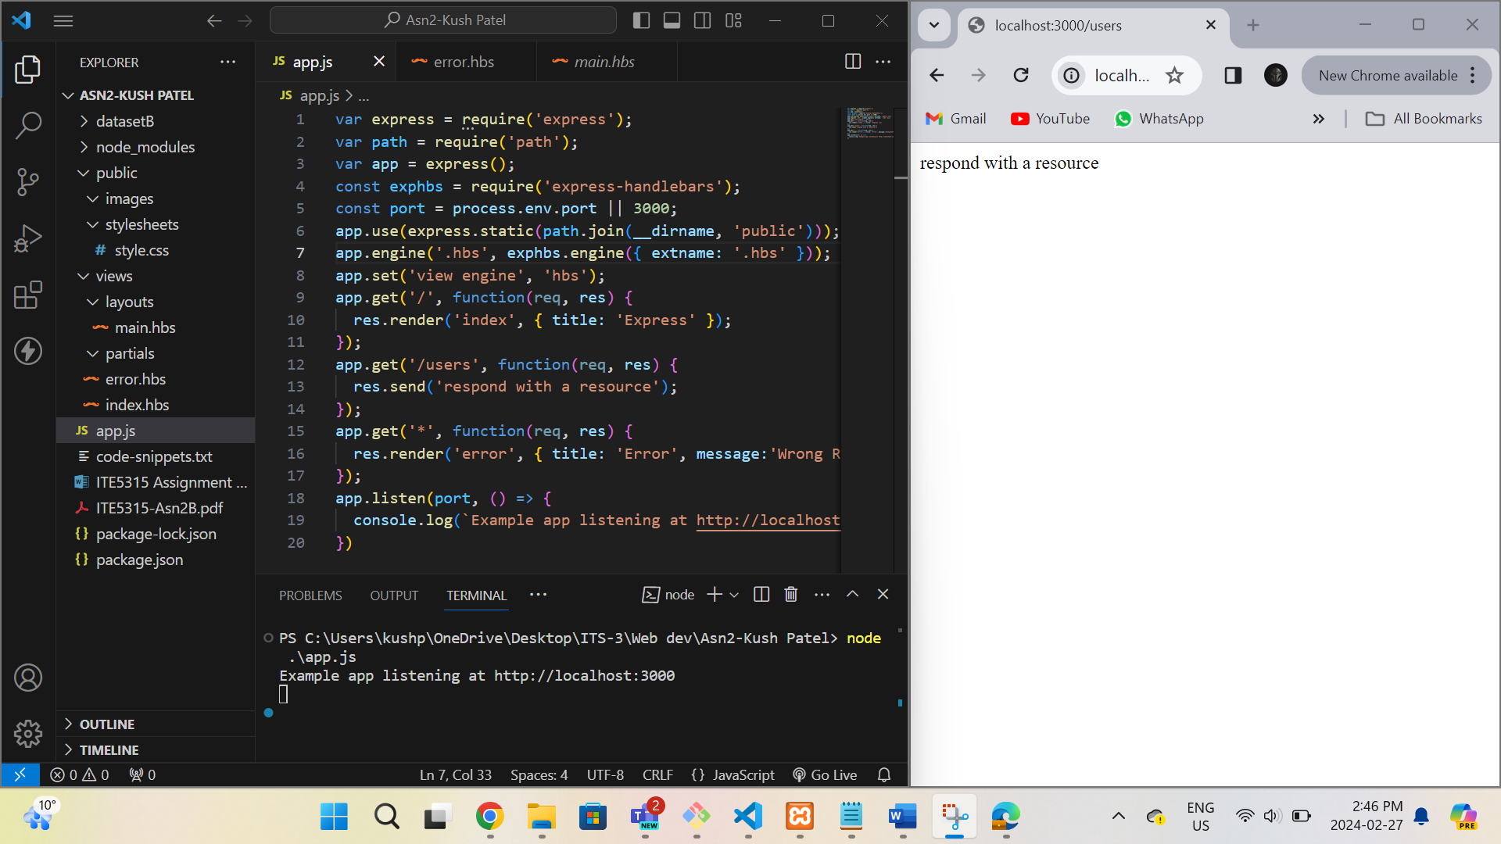

**URL:** [**http://localhost:3000/notExist**](http://localhost:3000/notExist)

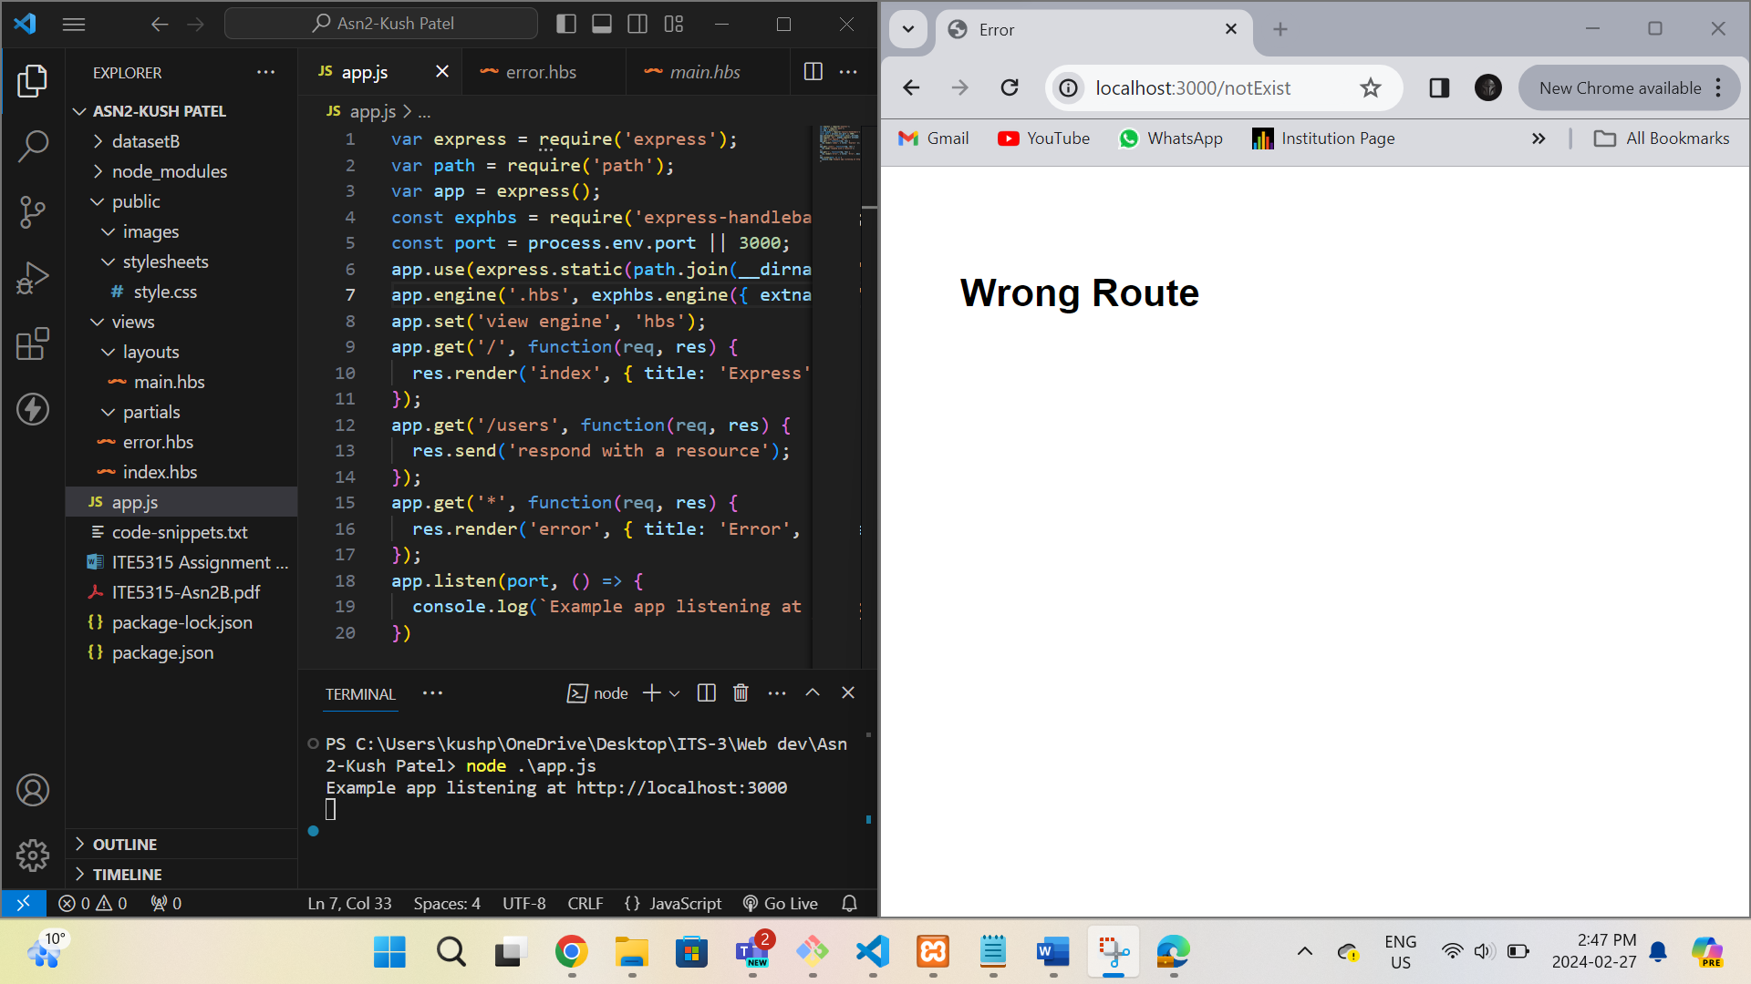

**Step 4:**

1. **What is the role of “main.hbs”? How does it being used/called in the app?**

main.hbs serves as the main layout template for the application's HTML pages. It provides the basic structure shared across different pages, including header, footer, and main content sections. It is called in the app through the rendering process, where the content of each page is injected into the {{{body}}} placeholder within "main.hbs".

1. **What is the role of “index.hbs” and “error.hbs”? How do these files being used/called in the app?**

index.hbs is a template for the homepage of the application. It is used to render the content of the index route ("/") and display a welcome message.

"error.hbs" is a template for error pages. It is used to render error messages when the user accesses a route that does not exist or when an error occurs in the application.

1. **In “app.js”, what is the role of the following line? What happen if you commend it out?**

The line **app.use(express.static(path.join(__dirname, "public")));** serves to set up a static directory to serve static files such as images, CSS, JavaScript, etc. The express.static middleware function is used to serve static files from the specified directory.

If we comment out this line, the server will not be able to serve any static files from the "public" directory. This means that any CSS, JavaScript, or image files referenced in your HTML files using relative paths will not be loaded properly.

**Step 5: In this step I have created header, footer and main content section to display dynamic content from different URLs.**

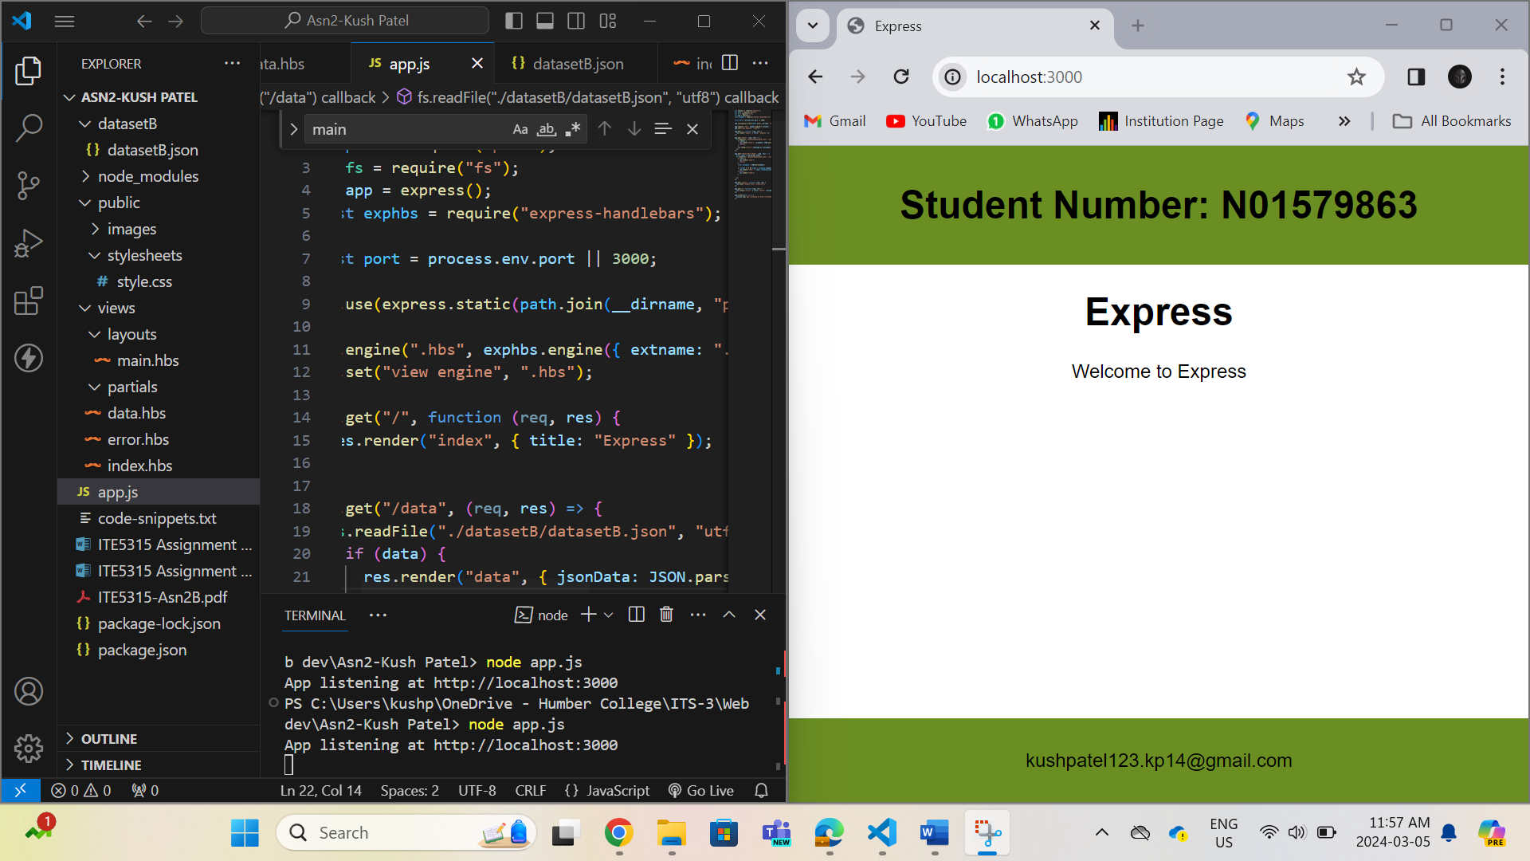

**Step 6: In this step I have created all the routes from the assignment 1 and tried to display the data based on the various requests.**

**URL –** [**http://localhost:3000/data**](http://localhost:3000/data)

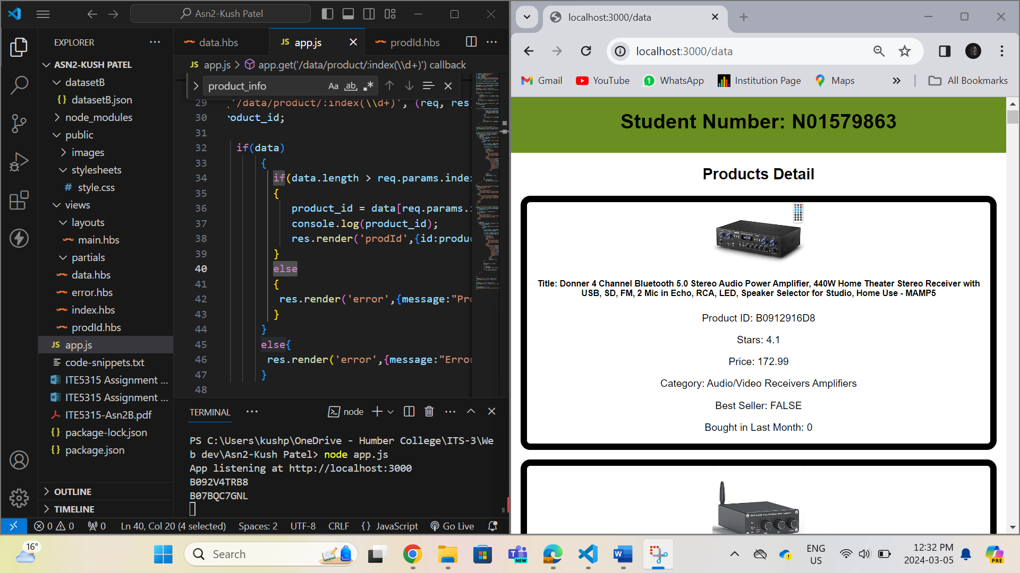

**URL -** [**http://localhost:3000/data/product/1**](http://localhost:3000/data/product/1)

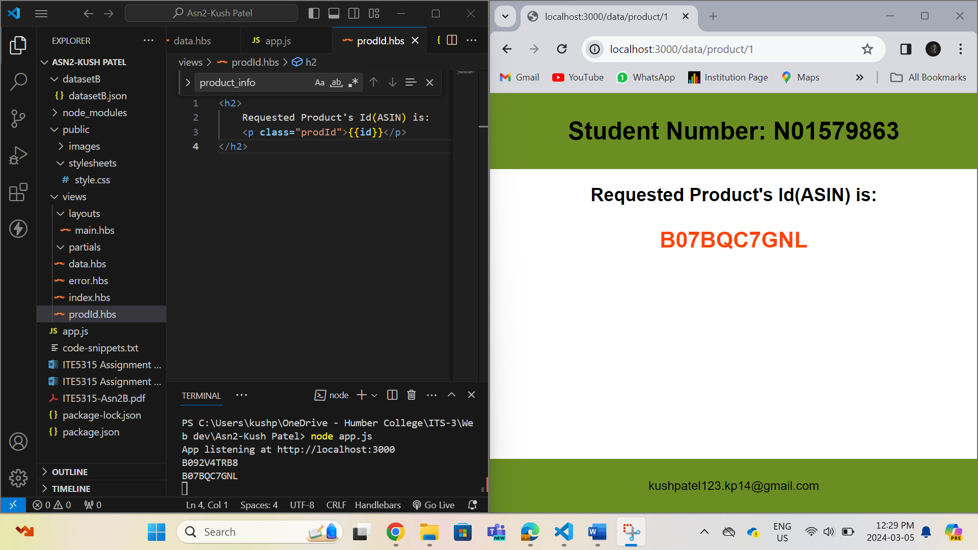

**URL -** [**http://localhost:3000/data/product/1787878787**](http://localhost:3000/data/product/1787878787)

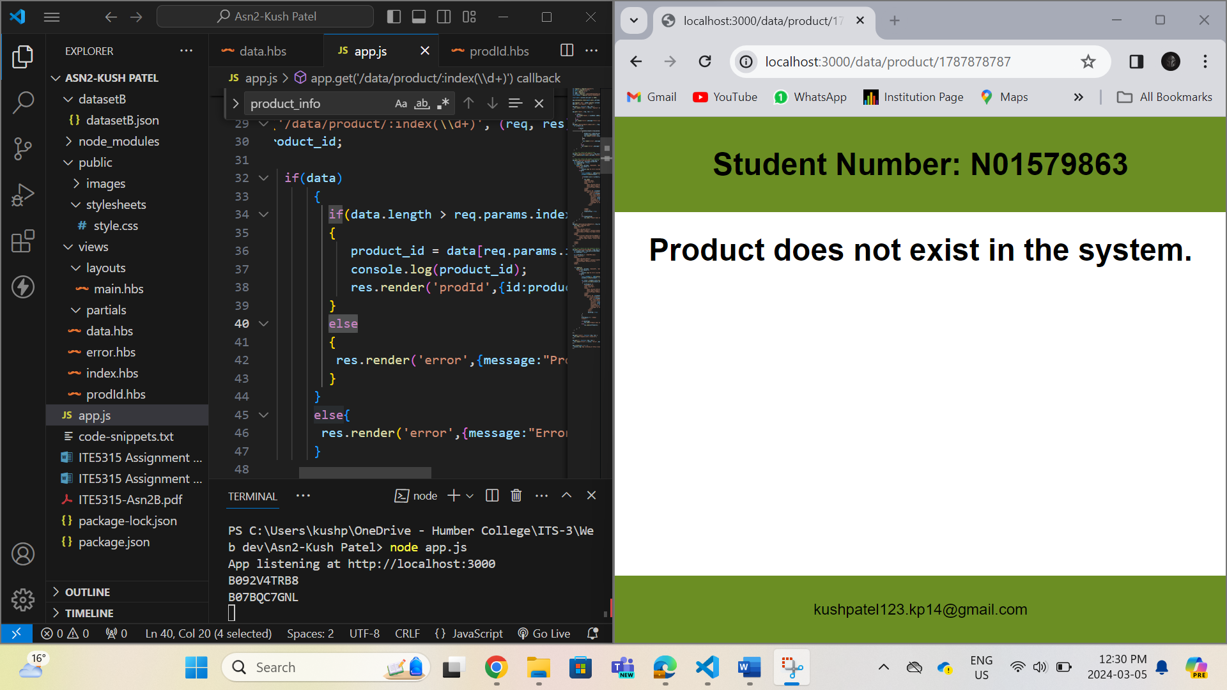

**URL -** [**http://localhost:3000/data/search/prdIDform**](http://localhost:3000/data/search/prdIDform)

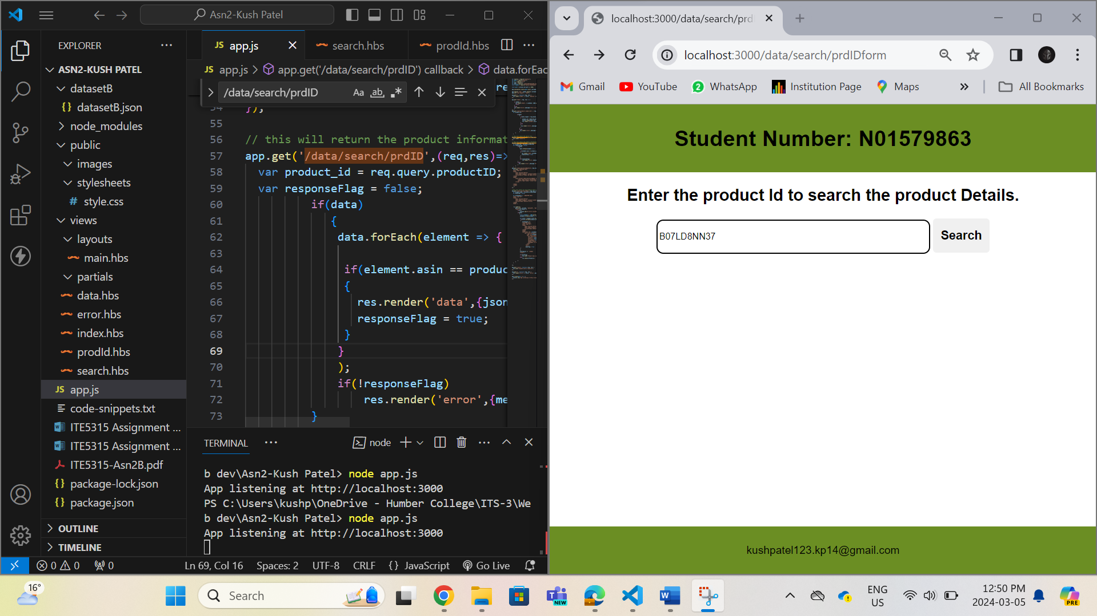

**URL -** [**http://localhost:3000/data/search/prdID?productID=B07LD8NN37**](http://localhost:3000/data/search/prdID?productID=B07LD8NN37)

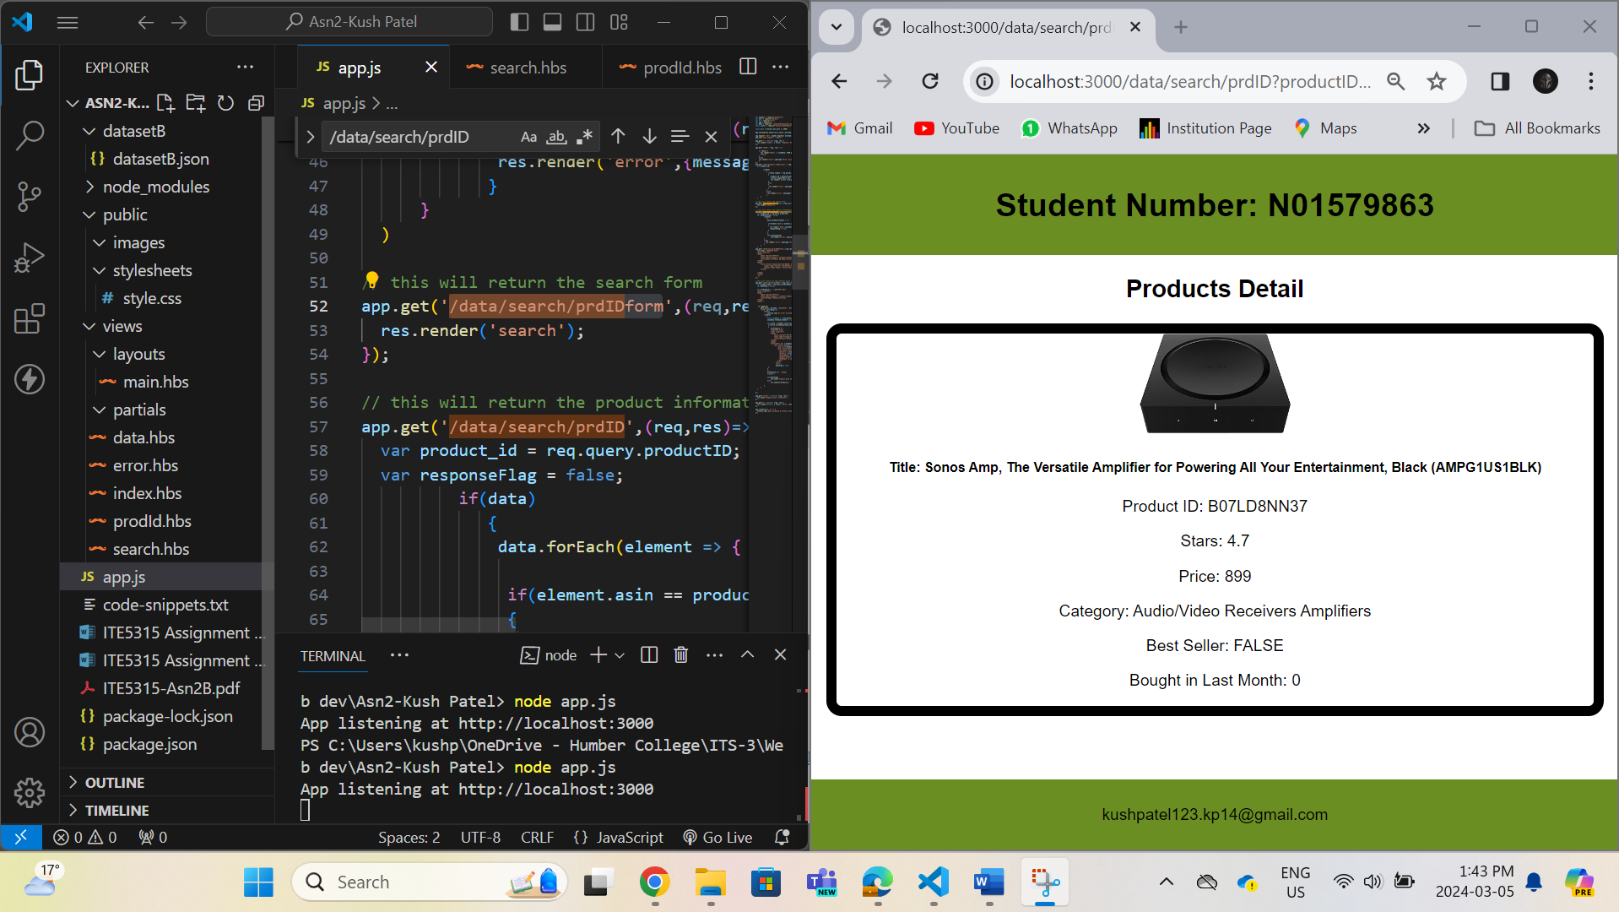

**URL –** [**http://localhost:3000/data/search/prdNameform**](http://localhost:3000/data/search/prdNameform)

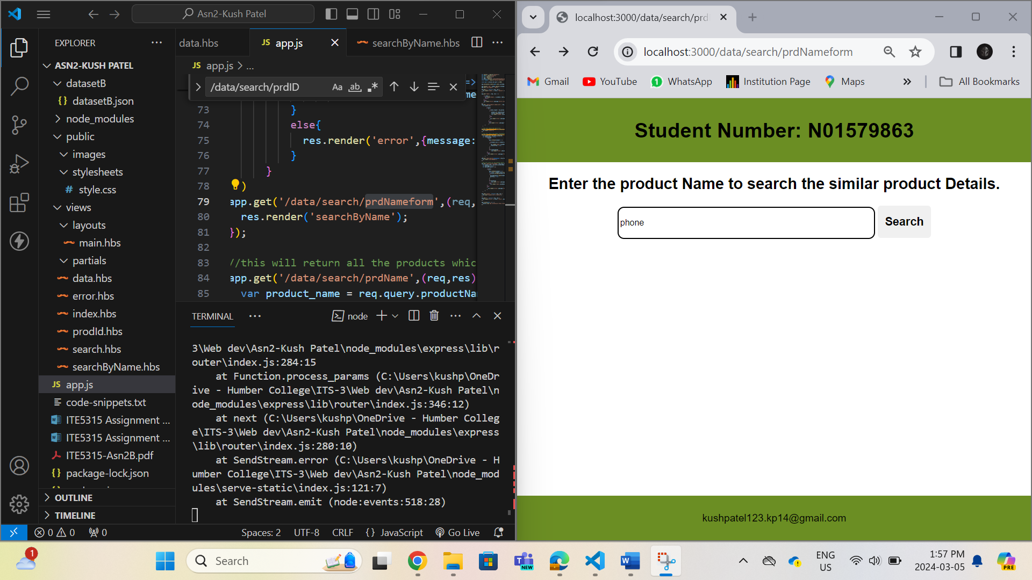

**URL –** [**http://localhost:3000/data/search/prdName?productName=phone**](http://localhost:3000/data/search/prdName?productName=phone)

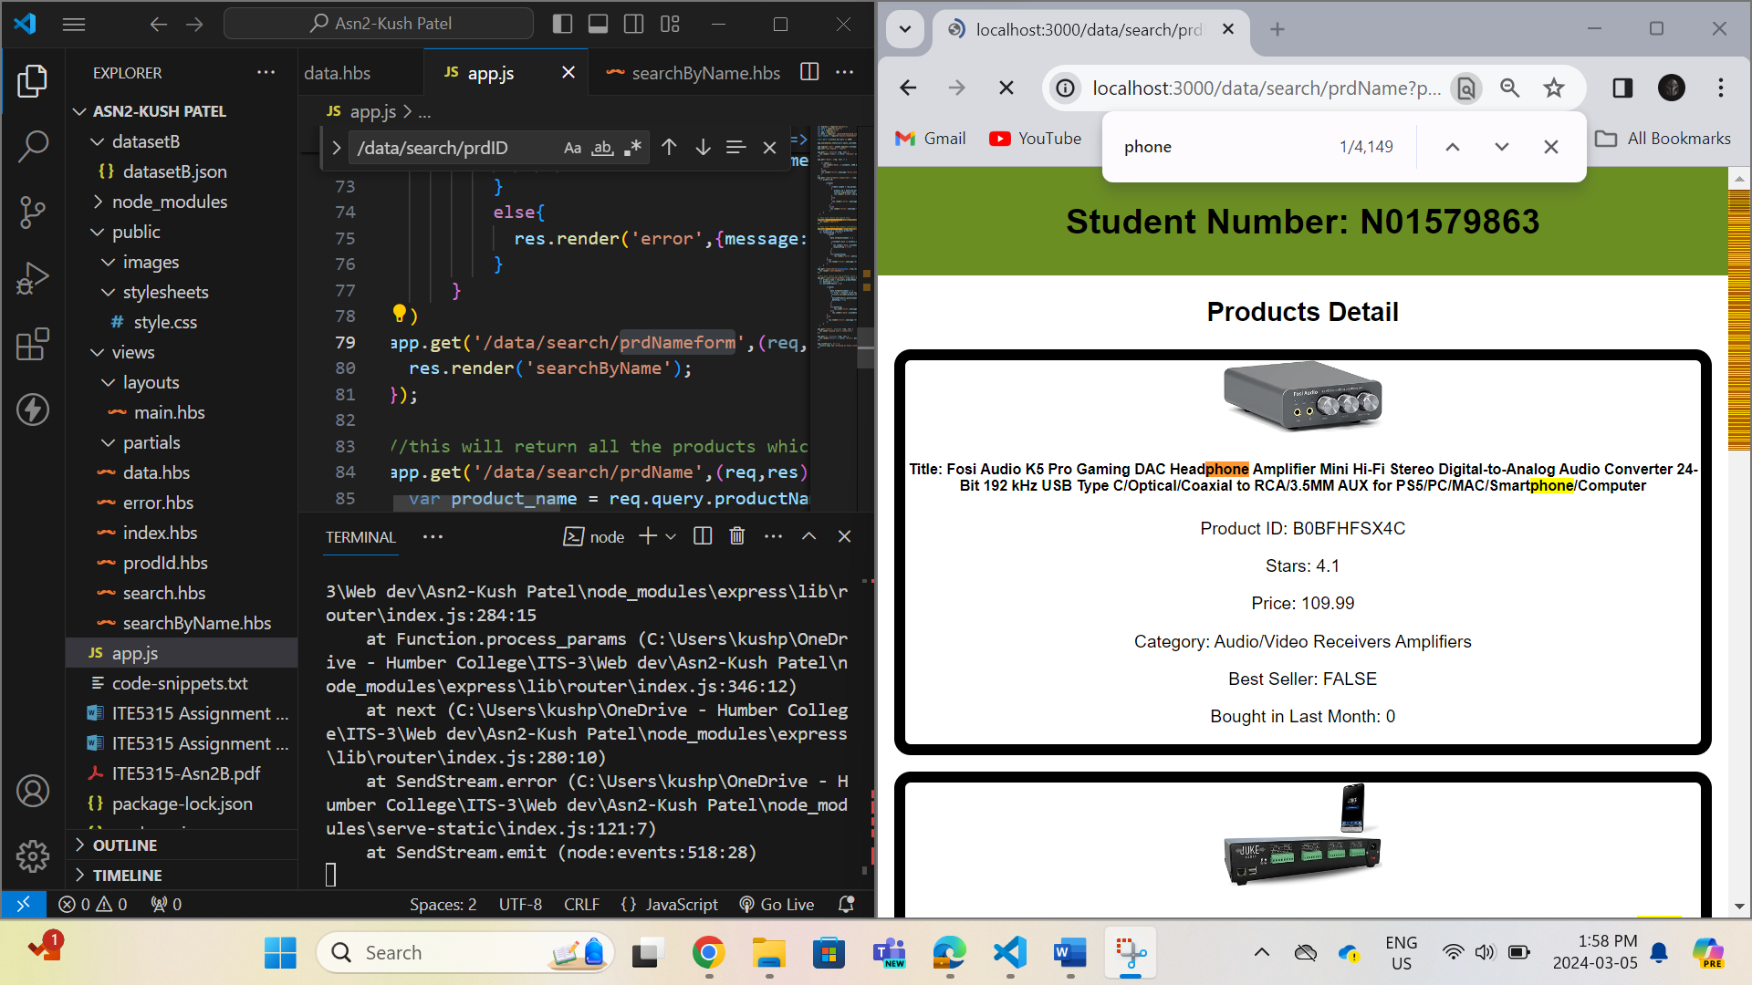

**Step 7: In this step I have tried to display all the available data from the file.**

**URL –** [**http://localhost:3000/allData**](http://localhost:3000/allData)

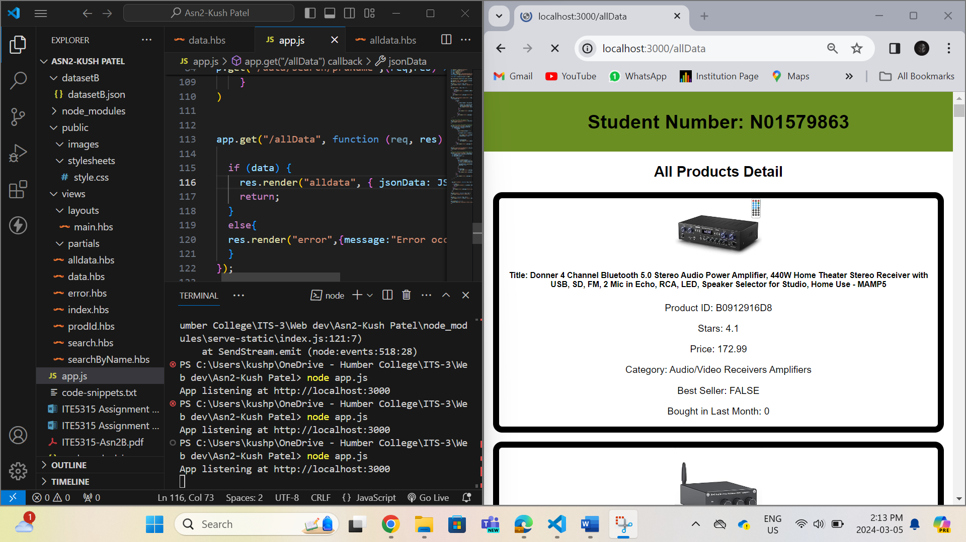

**Step 8: In this step I have displayed all the products which reviews are not 0 by using the if helper.**

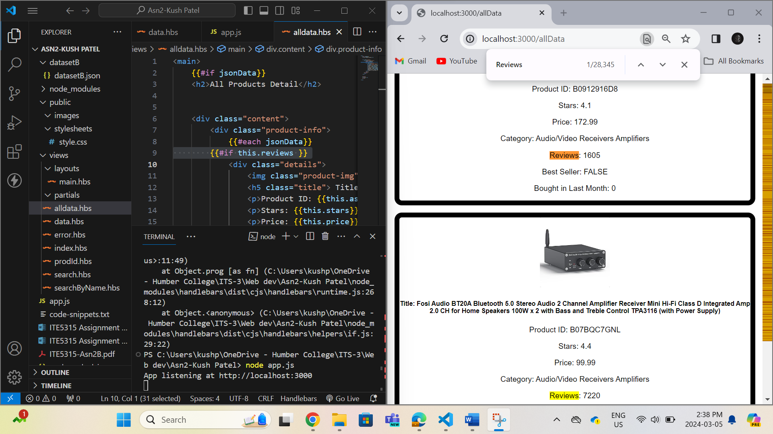

**Step 9:In this step I have created a custom helper which will accept reviews value and if it is 0 then it will change to N.A.**

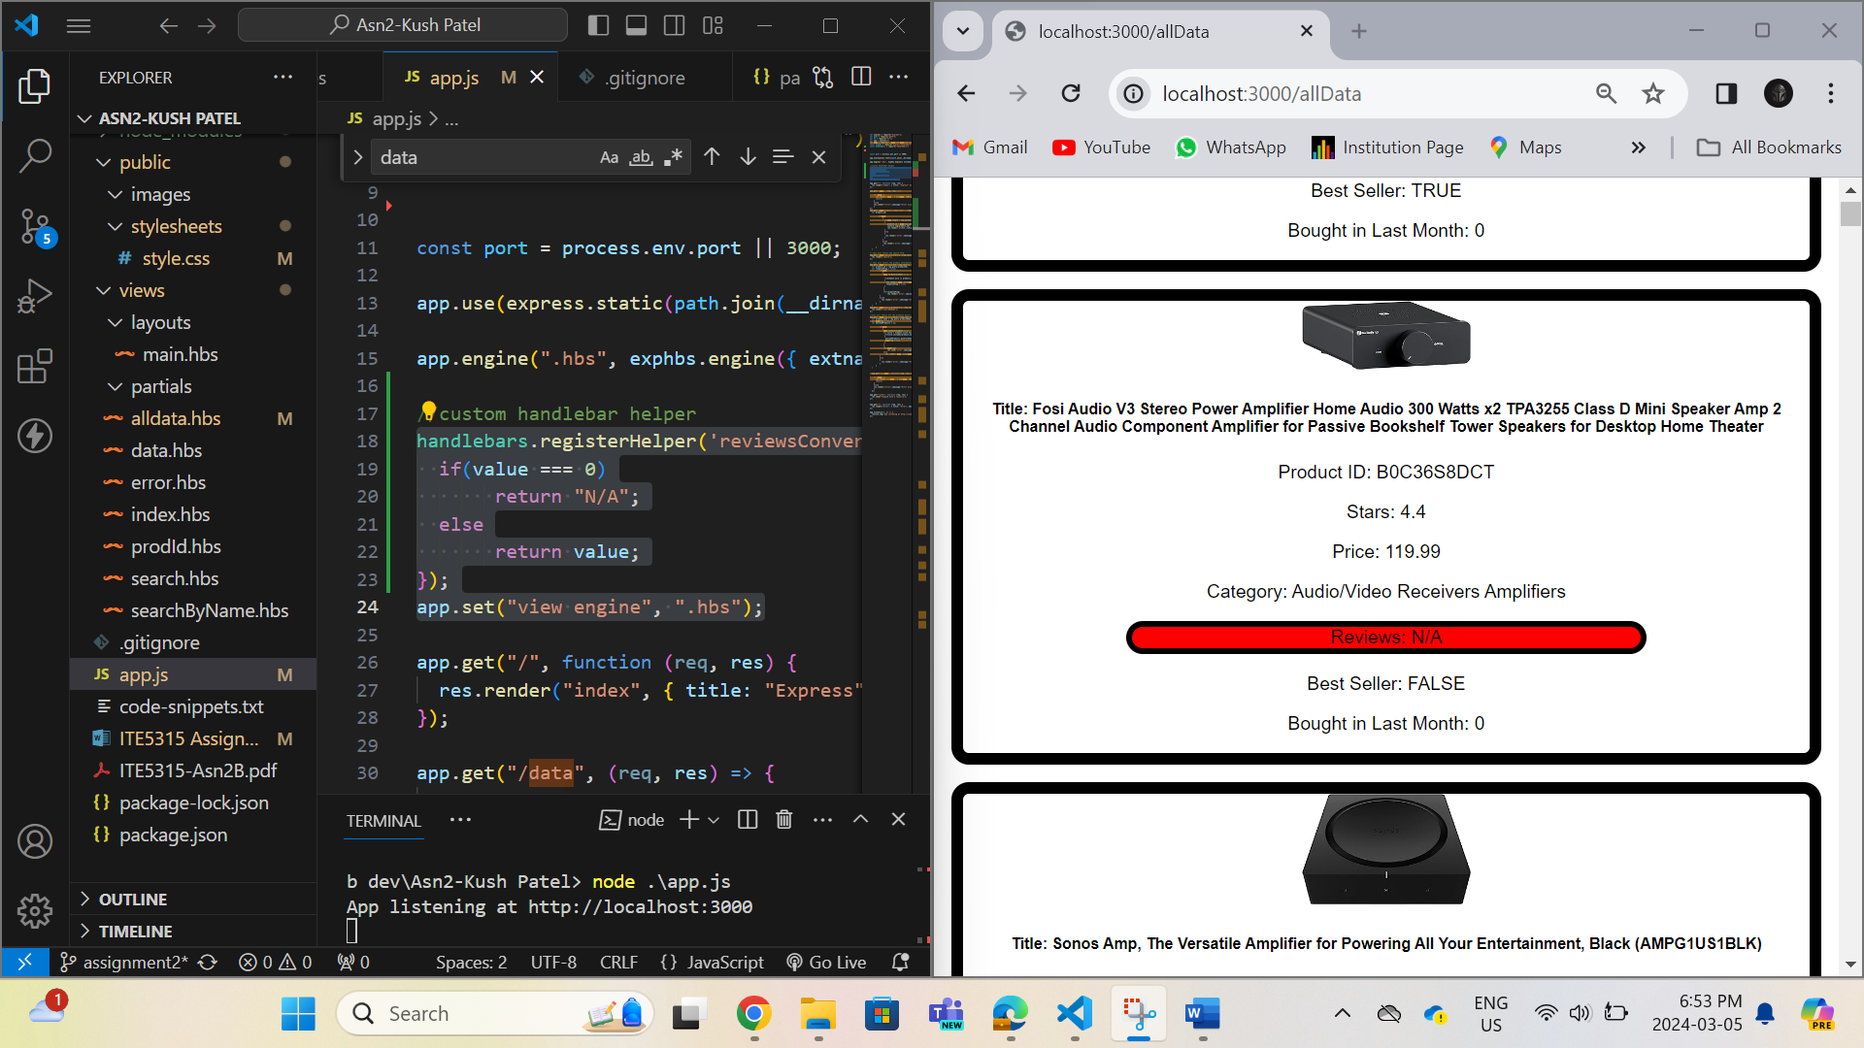

**Step 10: In this step I have highlighted the Reviews details by using background color red.**

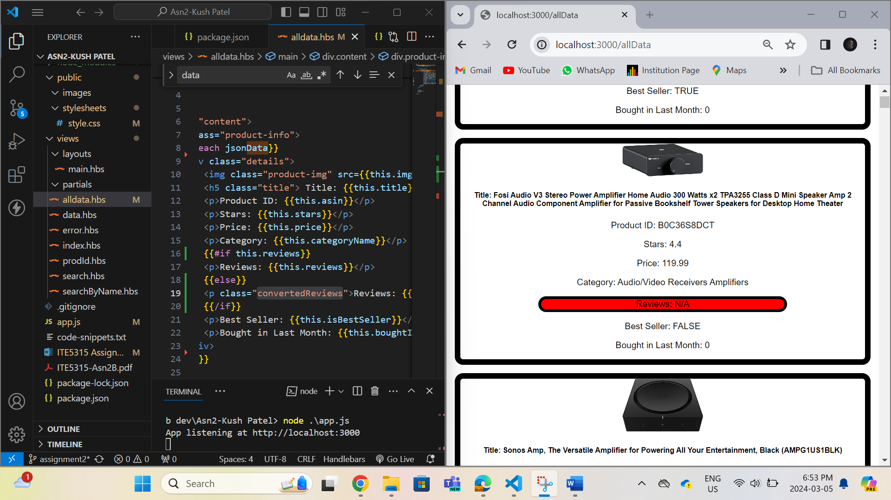

**Step 11:**

**URL -** [**https://fair-erin-snapper-hose.cyclic.app/**](https://fair-erin-snapper-hose.cyclic.app/) **this is the base url to access all the routes.**

